**Question 11 (4 marks)**

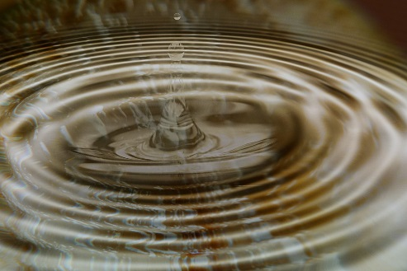 A stone is dropped into a still pool of water. It generates 20 waves that spread out a distance of 10.0 m from where it entered the water. The outer wave covers the 10.0 m in a time of 5.00 s and the average height of the waves is 10.0 mm (crest to trough).

1. Determine the wavelength and velocity of the waves. (2 marks)



$λ= \frac{10}{20}=0.5 m$ $v = d/t = 10/5 = 2ms^{-1}$

(1m each)

1. Calculate the period of the water waves. (2 marks)

$$T=\frac{λ}{v}=\frac{0.5}{2 } \left(1m\right)$$

$$=0.25 sec \left(1m\right)$$

**Question 14 (13 marks)**

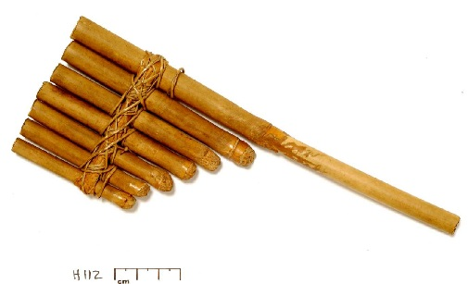 Panpipes, or pan flutes, can be traced back to Greek, Mayan, Native American, and many other ancient cultures. Although the sizes and styles differ across cultures, the basic design is a series of closed-end tubes of varying length, fixed together.

The sound is produced by blowing into the pipes and setting the column of air inside into motion. Once the wave pattern is stabilized it is known as a standing wave.

1. Will the closed end of the tube always serve as a displacement node or a displacement antinode? Briefly explain your answer in terms of interference of waves.

(2 marks)

As a **node**. **(1m)**

Oncoming and reflected wave are 180o out of phase and hence **destructively interfere**, creating a node. **(1m)**

1. Determine the relationship between the wavelength of the **fundamental** frequency and the length of the tube. (1 mark)
$$λ=4l$$

2. If a pipe of length 30.4 cm was made to resonate at its fundamental frequency, calculate the frequency of sound produced. (2 marks)
$${f }_{1}=\frac{v}{4l }=\frac{346}{4×0.304} \left(1m\right)$$

$$=26.30 Hz \left(1m\right)$$

3. The tube is now vibrating with a standing wave pattern of three antinodes and three nodes. State which overtone this represents. Draw a particle displacement diagram below to aid your answer. (2 marks)

Overtone: 1st (3rd harmonic) **(1m)**

**Sketch (1m)**

1. A student wishes to make another pipe that produces sounds 1 octave above this (i.e twice its frequency). What length pipe will she need to make? Justify your answer. (2 marks)
$$recognise that f∝\frac{1}{l} \left(1m\right)$$

$$hence make the new pipe HALF as long. \left(or 15.2 cm\right) \left(1m\right)$$

2. An internet guide to making your own panpipe suggests that each pipe is 9/8 the length of the previous. One of the pipes resonates at its 3rd harmonic, producing an A note of 440 Hz.

Calculate the frequency of the fundamental note produced by the pipe 3 “steps” longer than this. (4 marks)

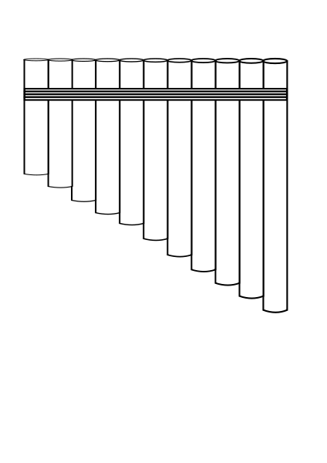 $$l_{1}=\frac{3v}{4f}=\frac{1038}{1760}=0.590 m \left(1m\right)$$

$${ l}_{3}=0.590×{\frac{9}{8}}^{3} \left(1m\right)$$

$$=0.84 m \left(1m\right)$$

$${f }_{1}=\frac{v}{4l }=\frac{346}{4×0.84}=102.97 Hz \left(1m\right)$$

**Section Three: Comprehension 20% (36 Marks)**

This section contains **two (2)** questions. You must answer both questions. Write your answers in

the spaces provided. Suggested working time for this section is 40 minutes.

**Question 20 (18 marks)**

**The Great Eastern Japan Earthquake and Tsunami**



On March 11, 2011 at 2:45 pm a massive earthquake occurred off the North-East Coast of Japan. The hypocentre was at an underwater depth of approximately 29 km.

Less than an hour after the earthquake, the first of many tsunami waves hit Japan's eastern coastline. It is estimated that the Tsunami waves were travelling at about 340 kmh-1 with wavelengths averaging 280 km when they encountered the coastline. The tsunami waves reached run-up heights (how far the wave surges above sea level as it hits the land) of up to 39 metres at Miyako city and travelled inland as far as 10 km in some places.

The tsunami waves also travelled across the Pacific, reaching Alaska, Hawaii and Chile. In Chile, some 17,000 km distant, the tsunami waves were 2 metres high when they reached the shore. The earthquake produced a low-frequency rumble called infrasound, which travelled into space and was detected by the Goce satellite.

As well as the devastation from the Tsunami, several nuclear power stations were damaged, releasing significant amounts of radioactive material into the atmosphere. Some 55,000 households were displaced and evacuation zones of up to 100km from the reactors were established.

The following table is from reports released by Japan’s Atomic Energy Commission a year after the disaster, estimating the amount of various isotopes released into the atmosphere and the ocean:

|  |  |
| --- | --- |
| **Isotope** | **Estimated amount released (TBq)** |
| iodine-131 | 511,000 |
| caesium-134 | 13,500 |
| caesium-137 | 13,600 |
| strontium-90 | 8,300 |

* Iodine-131 is easily absorbed by the thyroid, so persons exposed to releases of I-131 have a higher risk of developing thyroid disease. Children are more vulnerable to I-131 than adults. I-131 decays by beta minus and gamma emissions with a short half-life at 8.02 days.
* Caesium-137 has a long, 30-year half-life. Internal exposure to Cs-137, through ingestion or inhalation, allows the radioactive material to be distributed in the soft tissues, especially muscle and lung tissue, exposing these tissues to the beta particles and gamma radiation.
* Strontium-90 behaves like calcium (20–30% of ingested Sr-90 is absorbed and deposited in the bone and bone marrow). It undergoes β− decay into Yttrium-90, with a half-life of 28.8y.

On 22 March, World Nuclear News reported that 6 workers had received over 100 mSv, and one of over 150 mSv.On 24 March, three workers required hospital treatment after radioactive water seeped through their protective clothes. The injuries indicated exposure of 2000 to 6000 mSv around their ankles, with whole body doses of about 170 mSv. They were not wearing protective boots, as their employing firm's safety manuals "did not assume a scenario in which its employees would carry out work standing in water at a nuclear power plant".

**Questions:**

1. As the Tsunami waves travel in deep water, they can be approximated as a sine wave. On the diagram below, clearly indicate the amplitude and wavelength of the wave. 1m each (2 marks)

displacement

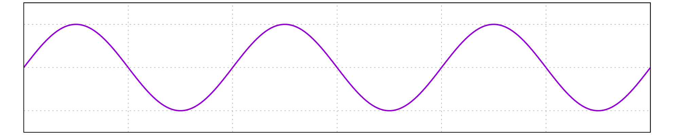

Wavelength

Amplitude

Distance from source

1. Calculate the time between two successive waves hitting Japanese the coastline. (1 mark)

$T=\frac{λ}{c}= \frac{280}{340}=0.8235 hrs or 49.4 min$**(1m)**

1. As a result of their long wavelengths, tsunamis act as shallow-water waves. A wave becomes a shallow-water wave when the wavelength is very large compared to the water depth. Shallow-water waves move at a speed, *c*, that is dependent upon the water depth and is given by the formula:

$$c= \sqrt{gH}$$

where *g* is the acceleration due to gravity and *H* is the depth of water, in metres.

1. Refer to the equation above to state what would happen to the speed of the tsunami wave as it approached the shore.

(1 mark)

As $∝\sqrt{H}, c would decrease as depth gets shallower. \left(1m\right)$

1. Calculate how long after the earthquake the Tsunami wave would reach the shore of Chile if the average ocean depth is 3.00 km. (3 marks)
$$t= \frac{d}{\sqrt{gH}} \left(1m\right)$$

$$= \frac{17×{10}^{6}}{\sqrt{9.8×3×{10}^{3}}} \left(1m\right)$$

$$=99146\sec{ or 27.5 hrs} \left(1m\right)$$

2. Explain why the wave height would only be around 2m when it reached Chile. (2 marks)

* Wave attenuates due to friction, etc.

$I ∝\frac{1}{r^{2}}, so Intensity falls with distance away.$

$Or similar resonable explanation$

1. Complete the diagram below to show how the Tsunami waves behave around and beyond a large island.

Shows **Diffraction** around the island.

(2 marks)

Direction of motion

1. Which of the isotopes mentioned would cause the most serious health risks in the first weeks after the incident? Explain your answer. (2 marks)

Iodine 131 **(1m)**

as it has a short half life of 8.02 days. **(1m)**

1. Calculate the percentage of the total fallout was from I-131. (1 mark)

$$\frac{511 000}{546 400} ×100=93.5\%$$

1. Calculate the amount (in TBq) of Iodine131 that remained 30 days after the accident.

(2 marks)

$$\frac{A}{A_{o}}={\left(\frac{1}{2}\right)}^{n}$$

$$A= 511 000× {\left(\frac{1}{2}\right)}^{\frac{30}{8.02}} \left(1m\right)$$

$$=3.82 x {10}^{4} TBq \left(1m\right)$$

1. Calculate how much energy would need to be absorbed by a 75.0 kg person for them to receive a whole body dose of 170 mSv. (2 marks)

$$E=AD ×mass$$

$$=170×{10}^{-3} ×75 \left(1m\right)$$

$$=12.75 J \left(1m\right)$$

**Question 5 (5 marks)**

Dolphins use high frequency clicks in the range of 40.0 kHz to 150 kHz for echolocation.

1. If the speed of sound in water is 1480 m s-1, calculate the wavelength of a 150 kHz click.

(2 marks)

|  |  |
| --- | --- |
| **Description** | **Marks** |
| $v=fλ$ $λ=\frac{v}{f}$ $=\frac{1480}{150×{10}^{3}}$ | 1 |
| $λ=9.87 mm or 9.87 ×{10}^{-3}m$ | 1 |
| **Total** | **2** |

1. If a stationary dolphin emits a click and it takes 150 ms for the click to return to the dolphin from the sea floor, calculate the distance from the dolphin to the sea floor.

(3 marks)

|  |  |
| --- | --- |
| **Description** | **Marks** |
| $v=\frac{s}{t}$ $s=v×t$ $=1480×0.15$ | 1 |
| $d=222 m$ | 1 |
| Distance to sea floor is half of the total distance that the sound travels. $d_{floor}=\frac{222}{2}=111 m$ | 1 |
| **Total** | **3** |

**Question 8 (5 marks)**

In February, 1933, the USS Ramapo, a 146 metre navy vessel found itself in an extraordinary storm on its way from Manila to San Diego. The storm lasted 7 days and stretched from the coast of Asia to New York, producing strong winds over thousands of miles of unobstructed ocean. During the storm the crew had time to carefully observe the nearly sinusoidal ocean waves. The plot shows a displacement-time graph of waves similar to that recorded by the USS Ramapo.

1. Use the graph to determine the amplitude of the waves. (1 mark)
2. Use the graph to determine the period of the wave. (1 mark)
3. If the period of a wave is 15.0 s and its speed is 23.0 m s-1, calculate its wavelength.

(3 marks)

|  |  |
| --- | --- |
| **Description** | **Marks** |
| (a) $34 m±1 m$ | 1 |
| (b) $15 s±1 s$ | 1 |
| (c) $v=fλ=\frac{λ}{T}$ | 1 |
| $λ=v×T$ $=23.0×15$ $=345 m$ | 1-2 |
| Alternatively for (c) $f=\frac{1}{T}=\frac{1}{15}=0.0667 Hz$ (1 mark) $λ=\frac{v}{f}=\frac{345}{0.0667}=345 m$ (2 marks) |  |
| **Total** | **5** |

**Question 17 (17 marks)**

Jacqueline and Kieran set up an experiment to determine the power output of a loudspeaker. In this investigation they measured the sound intensity $I (W m^{-2}$) produced by the loudspeaker at several different distances $r(m)$ from it. Their experimental setup is shown below.



r

Power output P

The equation which relates the power output of the speaker, the sound intensity and the distance from the speaker is

$$I=\frac{P}{4πr^{2}}$$

where



$I=sound intensity ({W m}^{-2})$

$P=power output of the speaker \left(W\right)$

$r=distance from the speaker (m)$

A table of results for this investigation is shown below:

|  |  |  |
| --- | --- | --- |
| r (m) | I (W m-2) | 1/r2 |
| 0.500 | 39.7 | 4.00 |
| 0.750 | 16.8 | 1.78 |
| 1.50 | 4.20 | 0.444 |
| 3.00 | 1.10 | 0.111 |

1. Complete the last column in the table above. Give your answers to three significant figures.

(4 marks)

1. On the graph paper provided plot $1/r^{2}$ versus sound intensity $I$. Plot $1/r^{2}$ on the *x*-axis and sound intensity on the *y*-axis. You must label your axes. (5 marks)

prac exam youngs mod 10 by 10

|  |  |
| --- | --- |
| **Description** | **Marks** |
| (b) |  |
| Correct axes labels | 1-2 |
| Correct scale on axes | 1 |
| Correct plotting of points | 1-2 |
| **Total** | **5** |
| (c) |  |
| Line of best fit is a straight line running through the middle of the points. | 1 |
| **Total** | **1** |

1. Add a line of best fit to your graph. (1 mark)
2. Using your line of best fit, determine the sound intensity 0.9 m from the speaker.

(2 marks)

|  |  |
| --- | --- |
| **1Description** | **Marks** |
| When r = 0.9 m, 1/r2 = 1/0.92 = 1.23 m-2 | 1 |
| From the line of best fit  I = 12 W m-2  Accept values for intensity between 11 and 13 W m-2 | 1 |
| **Total** | **2** |

1. Determine the gradient of your line of best fit. You must show your rise and run on the graph.

(3 marks)

|  |  |
| --- | --- |
| **Description** | **Marks** |
| Rise and run shown on the graph. | 1 |
| $gradient=\frac{rise}{run}=\frac{39.5-4.7}{4-0.5}$ | 1 |
| $gradient=9.94 W$ | 1 |
| No unit for gradient is necessary. |  |
| **Total** | **3** |

1. The sound intensity equation can be written as

$I=\frac{P}{4π}×\frac{1}{r^{2}}$

The term $\frac{P}{4π}$ in the above equation is equal to the gradient of the line of best fit which you calculated in Part e). Using

$gradient=\frac{P}{4π}$

calculate the power of the source P. If you did not calculate the gradient use a value of 9.90 W. (2 marks)

|  |  |
| --- | --- |
| **Description** | **Marks** |
| $gradient=\frac{P}{4π}$ $P=gradient ×4π$ $=9.94×4×π$ | 1 |
| $P=125 W$ | 1 |
| **Total** | **2** |

**Section Three: Comprehension 20% (36 Marks)**

This section contains **two (2)** questions. You must answer both questions. Write your answers in the space provided. Suggested working time for this section is 40 minutes.

**Question 20 (18 marks)**

**The Ear**

The human ear is used for both hearing and balance and acts as transducer which converts sound energy to a nerve impulse which is sent to the brain. The ear allows us to detect pressure variations in the air which are less than one billionth of atmospheric pressure. It is able to detect these pressure variations within a range from 20 Hz to 20 kHz.

The ear comprises the outer ear, middle ear and inner ear and each part has a different function. When a sound wave is produced it travels at 340 m s-1 from the source and spreads out in three dimensions. The large area of the Pinna collects the sound and focuses it down the auditory canal. The auditory canal acts like a pipe closed at one end and resonance occurs within its length. The peak sensitivity of the ear to sound occurs at 3700 Hz which corresponds to the fundamental resonant frequency of the auditory canal.

The sound travels down the auditory canal to the ear drum. The sound vibrates the ear drum which vibrates the ossicles which are the three bones of the middle ear and the smallest bones in the body. The ossicles further amplify the sound.

The vibrating bones of the middle ear produce longitudinal waves in the fluid of the cochlea in the inner ear. The cochlea transforms the energy of the waves into nerve impulses which are transmitted to the brain.

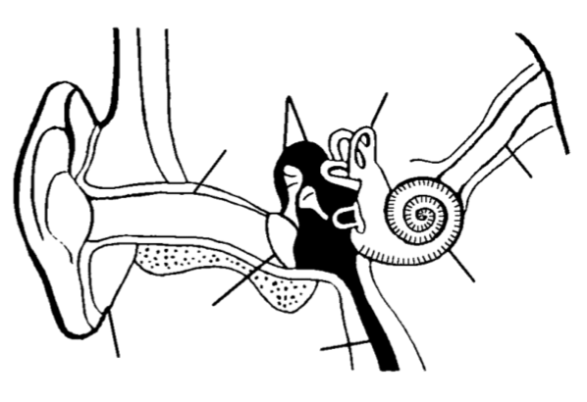

Pinna

Auditory Canal

Ear drum

Cochlea

Ossicles



Auditory nerve

1. Vibration of the bones in the middle ear produces longitudinal waves in the cochlea. Explain how longitudinal waves are different from transverse waves.

(2 marks)

|  |  |
| --- | --- |
| **Description** | **Marks** |
| For longitudinal waves the direction of particle vibration is in the same direction as the velocity of the wave. | 1 |
| For transverse waves the direction of vibration of the particles is perpendicular to the velocity of the wave. | 1 |
| **Total** | **2** |

1. If sound enters the ear canal with a frequency of 20.0 kHz how many sound waves enter the ear in 25.0 ms. (2 marks)

|  |  |
| --- | --- |
| **Description** | **Marks** |
| $n=f×t$ $=20×{10}^{3}×25.0×{10}^{-3}$ | 1 |
| $n=500 waves$ | 1 |
| **Total** | **2** |

1. Calculate the wavelength of sound vibrating at the fundamental resonant frequency of the auditory canal. You can assume that the speed of sound is 340 m s-1. (3 marks)

|  |  |
| --- | --- |
| **Description** | **Marks** |
| $f=3700 Hz$ from article. | 1 |
| $v=fλ$ $λ=\frac{v}{f}$ $=\frac{340}{3700}$ | 1 |
| $=0.0919 m$ | 1 |
| **Total** | **3** |

1. Calculate the effective length of the auditory canal. If you did not calculate an answer for the previous question assume that the wavelength which corresponds to the fundamental frequency is 92.0 mm. (2 marks)

|  |  |
| --- | --- |
| **Description** | **Marks** |
| $λ=\frac{4l}{(2n-1)}$ $l=\frac{λ\left(2n-1\right)}{4}$ $=\frac{0.0919(2×1-1)}{4}$ | 1 |
| $l=0.0230 m$ or 23.0 mm | 1 |
| **Total** | **2** |

1. Calculate the frequency of the third harmonic. (1 mark)

|  |  |
| --- | --- |
| **Description** | **Marks** |
| $f_{3}=3f_{1}$ $=3×3700=11.1 kHz$ | 1 |
| **Total** | **1** |

1. The figures below represent the auditory canal. Draw the **pressure variation** for the first and third harmonics of the auditory canal.

2 marks per diagram

1 mark for correct position of pressure nodes and antinodes.

1 mark for correct shape.

*First harmonic* (2 marks)

*Third harmonic* (2 marks)

PN

PN

1. On the diagram above for the third harmonic label the pressure nodes. (1 mark)
2. Explain how standing waves are formed in the auditory canal. (3 marks)

|  |  |
| --- | --- |
| **Description** | **Marks** |
| Sound at the resonant frequency enters the ear. | 1 |
| The sound wave is reflected from the ear drum and constructively interferes with the incoming sound wave. | 1 |
| The constructive interference of the two waves causes the formation of a standing wave. | 1 |
| **Total** | **3** |

Question 7 (4 marks)

The diagram below shows a sound wave moving through air at 25°C. The sinusoidal graph above the sound wave indicates the variation in air pressure as the wave travels.

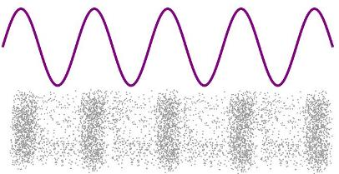

6.24 m

Pressure

Variation

SOUND

WAVE

(a) Calculate the value of each of the following quantities for this sound wave.

Wavelength: 1.56 m (6.24 m / 4 whole wave cycles) (1 mark)

Frequency: 222 Hz (346 m/s / 1.56 m) (1 mark)

Period: 4.51 x 10-3 s ( 1/222 Hz) (1 mark)

(b) On the pressure variation graph above, superimpose a sinusoidal graph to show the variation in particle displacement as the wave travels through the air. (1 mark)

(out of phase by 90º, movement of particles to right shown as positive)

Question 9 (4 marks)

Jimi is practicing guitar in his room with the door open, as shown in the diagram at right. With reference to relevant physics principles, explain why Joni, in the hallway outside his room, can hear the sound of the guitar but not see Jimi.



Wavelength of sound from guitar is of similar size to the doorway ✔

Sound waves will diffract significantly through the doorway ✔

Wavelength of light from Jimi is very small compared to the doorway ✔

Light waves will not diffract to any significant extent through the doorway ✔

Question 17 (15 Marks)

The clarinet, pictured at right, is a wind instrument that behaves like a closed pipe with a fundamental frequency of 130 Hz in air at a room temperature of 25ºC.

(a) What are the frequencies of the next two higher harmonics? (2 marks)

f3 = 3 x 130 Hz = 390 Hz ✔

f5 = 5 x 130 Hz = 650 Hz ✔

(b) Sketch the particle displacement vs distance envelopes for the fundamental frequency and for the next harmonic frequency above the fundamental for this instrument. (2 marks)

fundamental frequency

✔

next harmonic frequency

✔

(c) Calculate the length of the clarinet. (3 marks)

Fundamental frequency has wavelength

  = v / f = (346 m/s) / (130 Hz) = 2.66 m ✔

For fundamental frequency   = 4 L ✔

so length L =      = (2.66 m) / 4 = 0.665 m ✔

The clarinet is played so as to produce its fundamental frequency, and the sound is captured by a microphone and feed into an amplifier. Two loudspeakers X and Y are connected in phase to the amplifier and set up facing each other a distance of 8.5 m apart. A person walking from one of the loudspeakers towards the other hears points where the sound is extremely soft, alternating with points where it is loud.

X

Y

Amplifier

8.5 m

(d) Why will the person hear a series of soft and loud points as they walk from one loudspeaker towards the other? (2 marks)

As the person walks between the speakers, they alternately pass through points where the sounds from the two speakers arrive in phase and constructively interfere, giving a loud sound (✔), and other points where the sounds from the two speakers arrive out of phase and destructively interfere, giving a soft sound. (✔)

(e) Calculate whether the sound is loud or soft when the person walking between the loudspeakers is 2.92 m from speaker X. (3 marks)

Distance from speaker Y = 8.5 m - 2.92 m = 5.58 m ✔

Path difference = 5.58 m - 2.92 m = 2.66 m = 1  ✔

Hence waves interfere in phase 🡺 sound is loud ✔

(e) What is the distance between a soft and a loud point? (1 mark)

Distance between node and antinode = ¼  = ¼ (2.66 m) = 0.665 m ✔

(f) Determine the number of soft points between the loudspeakers. (2 marks)

Midpoint at 4.25 m from X is an antinode, so nodes occur between X and midpoint at

4.25 - 0.665 = 3.58 m , 4.25 - 3(0.665) = 2.25 m , 4.25 - 5(0.665) = 0.92 m ✔

Hence total number of nodes between X and Y = 6 ✔

**END OF SECTION TWO**

**Section Three: Comprehension (36 Marks)**

This section has **two (2)** questions. Write your answers in the spaces provided.

Suggested working time: 36 minutes.

|  |
| --- |
|  |

Question 21 LOCATION OF A SOUND (15 marks)

###### *(Paragraph 1)*

The precise method by which a human being is able to discover the location of a particular sound in relation to themselves has exercised the minds of scientists for many years. Lord Rayleigh, in his Theory of Sound published in 1896, comments briefly on the theory prevalent at the time. This was that the effect of the bulk of the head between the two ears produced a sound shadow, and thereby caused an amplitude difference in the sound reaching the two ears from a given source. Rayleigh pointed out that this theory could only operate at frequencies above about 1000 Hz, that is at frequencies above that at which the physical distance between the ears is equal to one wavelength. He suggested that a possible explanation for the perception of sound direction at low frequencies might be the difference in time of arrival of the sound wave from a source at the two ears.

*(Paragraph 2)*

Early workers conducting investigations into sound localisation were very limited in their activities by their lack of electrical equipment, and were forced to use clicks and other noises as sound sources. Furthermore, the rooms that they used for their experiments were far from good acoustically, and so the positions of the sound sources were confused by reverberation effects. However the early experimenters established that it is possible to locate noises more easily than pure tones, and that it is possible to distinguish sounds appearing from the right or the left.

*(Paragraph 3)*

Stevens and Newman, in 1934, devised an open-air experiment in order to overcome the difficulties of sound reflections. They mounted a swivel chair on top of the roof of one of the buildings at Harvard University. The source of the sound was mounted at the end of a four metre arm that could be moved noiselessly in a complete circle on a horizontal plane level with the listener’s ears. The sound generator was a loudspeaker that could produce pure tones and various noises, such as clicks. It was found that the listener hardly ever confused the positions of sounds that were to the right or left, but, depending upon the type of sound used, fairly frequent confusion of whether the sound was in front or behind took place. It was found that pure tones at low frequencies could be localised with reasonable accuracy, as could tones at very high frequencies, but there was a band of middle frequencies between 2000 and 4000 Hz where localisation appeared to be more difficult.

*(Paragraph 4)*

Stevens and Newman concluded that the observed results from their experiments were “consistent with the hypothesis that the localisation of low tones is made on the basis of a phase difference at the two ears, and that the localisation of high tones is made on the basis of intensity differences”. These experimental results seemed to confirm the earlier theories attributed to Rayleigh and others.

(a) Briefly explain what is meant by each of the following expressions

(i) …“an amplitude difference in the sound reaching the two ears”… (paragraph 1) (1 mark)

difference in loudness for sound reaching each ear ✔

(ii) …“pure tones”… (paragraphs 2 & 3) (1 mark)

single frequencies (no harmonics mixed in) ✔

(iii) …“a phase difference at the two ears”… (paragraph 4) (2 marks)

phase refers to the part of the cycle that a wave is at (✔) , so sound waves reach each ear at a different part of the wave cycle ✔

(b) What were the “difficulties of sound reflections” (paragraph 3) found by early experimenters in rooms which were “far from good acoustically” (paragraph 2)? (2 marks)

Sound waves would reflect off walls and other surfaces in the rooms (✔), causing the sound to appear to come from multiple positions in the room ✔

(c) Why does the frequency have to be above about 1000 Hz for the amplitude difference effect to be significant? (paragraph 1) (3 marks)

For frequencies above 1000 Hz the wavelength of the sound will be smaller than the size of the head (✔), so the sound will not diffract significantly around the head (✔), and the ear further away from the source of sound experiences a reduced amplitude of sound (✔)

(d) The information provided in paragraph 1 would enable you to make a very rough estimate of the speed of sound provided you make one further estimate of a simple measurement. Make an estimate of this simple measurement, and hence estimate the speed of sound. (3 marks)

Assume distance between ears = 25 cm (15 – 30 cm okay) ✔

Hence wavelength of sound at 1000 Hz = 25 cm ✔

v =  f = 0.25 m x 1000 Hz = 250 m/s ✔

(e) If the ear does detect sound direction for low frequencies by differences in times of arrival at the two ears, make a rough estimate of the time difference our hearing mechanism must be detecting. (paragraph 1) (3 marks)

Assume distance between ears = 25 cm (15 – 30 cm okay)

v = d / t (✔) 🡺 t = d / v = (0.25 m) / (346 m/s) ✔

= 7 x 10-4 s ✔